USING THIS Defibrillator – Patients 8+ years
ITEM | Description | ACTION
 | CALL 999 | Follow Directions given
 | Check for DANGER and a RESPONSE from the Patient | If Alone set up DEFIB
 | Place your cheek close to their mouth to check for breathing. Look at chest does it rise & fall.  - If they are breathing put the patient in the recovery position  - If they are not breathing CONTINUE  If with another person get them to Start Chest compressions - CPR  Staying Alive Beat 100 compressions per minute  5cm [2 inches] deep | Breathing  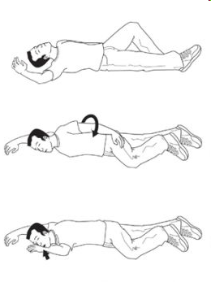  Not Breathing  Connect DEFIB
 | Open the DEFIB lid and follow voice prompts  “Tear open package and remove pads” | 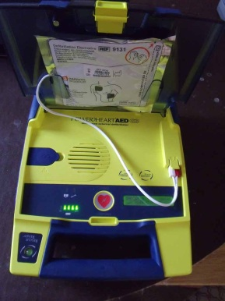
 | Remove patients clothing using the TUFF CUT SCISSORS – DO NOT DELAY BY UNDRESSING THEM | Expose bare chest  CUT away Coat, shirt , tee shirt vest or BRA
 | Remove any Chest hair using the RAZOR | Remove chest hair
 | DRY the CHEST if WET | Dry pad location
 | PLACE the ELECTRODES on the Chest as follows →  Remove the pad backing to expose the sticky surface then apply | 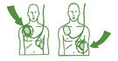
 | DEFIB will say “ANALYSING” do not touch or move the person during this phase | Allow Analysing to complete
 | DEFIB will say “SHOCKING” do not touch the person | Allow Shock to be delivered  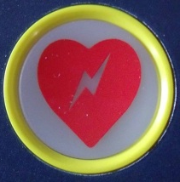
 | DEFIB will say “3” , “2” , “1” , “Shock Delivered” , “Safe to continue CPR” | Continue CPR
 | DEFIB might say “NO SHOCK ADVISED – Continue CPR” | Continue CPR
 | Keep going with CPR and Shocks until help arrives | Continue CPR / SHOCK Cycle
Under 8 years of age or After help arrives Please Turn Over
Patients younger than 8 years. You should be guided by the 999 Emergency Operator.

Thank you for your early intervention. Doing CPR and using this Defib has given the patient the best possible chance of survival.
Not every cardiac arrest can be treated, if you have used this Defib and not had a successful resuscitation and you need to talk please call Neil on 07557 439744.
Please now return the defib to its keepers and we will replenish the pads/mask/gloves. Please call Neil on 07557 439744 if no reply please call Shirley Burrill – Churt Parish Council Clerk on 01428 714274.
Thank you

